**Project Overview**

# **Project Title :** Urban Company

# **Description :** Discover the future of urban living with Urban Co, your one-stop solution for all things city life. We specialize in transforming your urban environment into a sanctuary of comfort, style, and efficiency. Our services range from home cleaning and repairs to interior design and lifestyle management, all tailored to meet the dynamic needs of city dwellers.

**Table of Contents**

* Project Overview :
  + **Professional Home Services:** From deep cleaning and pest control to plumbing and electrical repairs, our expert team ensures your home is always in top shape.
  + **Interior Design and Renovation:** Our design specialists work with you to create living spaces that reflect your style and maximize your space, bringing your urban living dreams to life.
  + **Personalized Lifestyle Solutions:** We provide concierge services, event planning, and organizational support to help you balance your busy schedule with ease.
  + **Sustainable Practices:** Committed to eco-friendly solutions, we use green products and sustainable methods to protect your home and the environment.
* Technology Stack :
  + **HTML5:** Utilized for creating a modern, responsive, and structured web layout that enhances user experience.

* + **CSS3:** Enables sophisticated design elements and animations, ensuring our website is both visually appealing and functional.

* + **Bootstrap:** Implements responsive design, ensuring our site looks great on any device, from smartphones to desktops.

* + **Fontawesome:** For different attractive icons.

* Features of Urban Company:
  + **Wide Range of Services:**
    - Comprehensive home services including cleaning, repairs, and maintenance.
    - Specialized services like pest control, painting, and appliance servicing.
  + Professional Expertise:

* + - Access to a network of skilled and certified professionals.

* + - Rigorous vetting and training processes to ensure quality and reliability.
  + User-Friendly Platform:
    - Intuitive website design with easy navigation and service selection.

* + - Seamless online booking system that allows for quick and hassle-free scheduling.

* + Responsive Design:

* + - Mobile-friendly website built using Bootstrap, ensuring accessibility on all devices.
    - Fast loading times and optimized performance for a smooth user experience.
* Setup and Installation:
  + Install a Web Browser:
    - Google Chrome
    - Mozilla Firefox
    - Microsoft Edge
    - Safari
* Code Structure :
  + 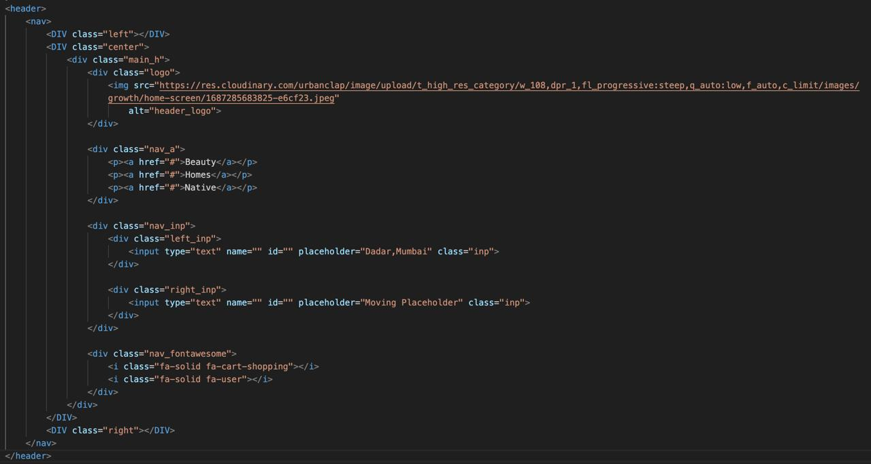Header :
  + Main Section : 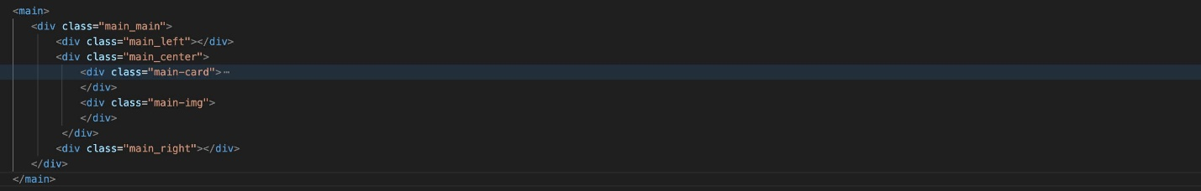
  + Card & Contents : 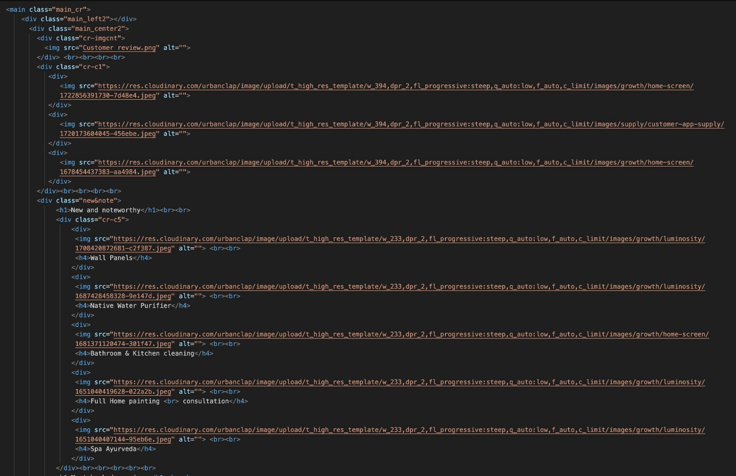

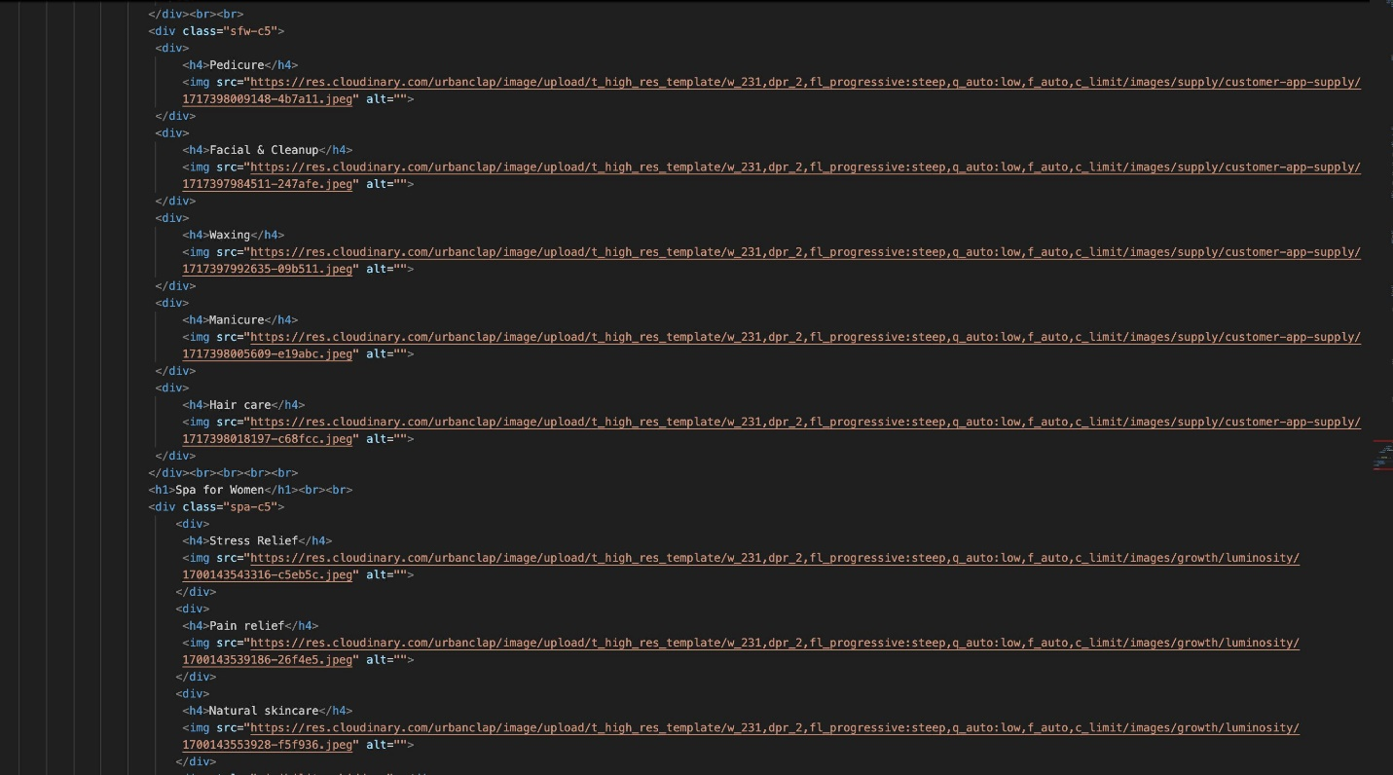

* + Footer : 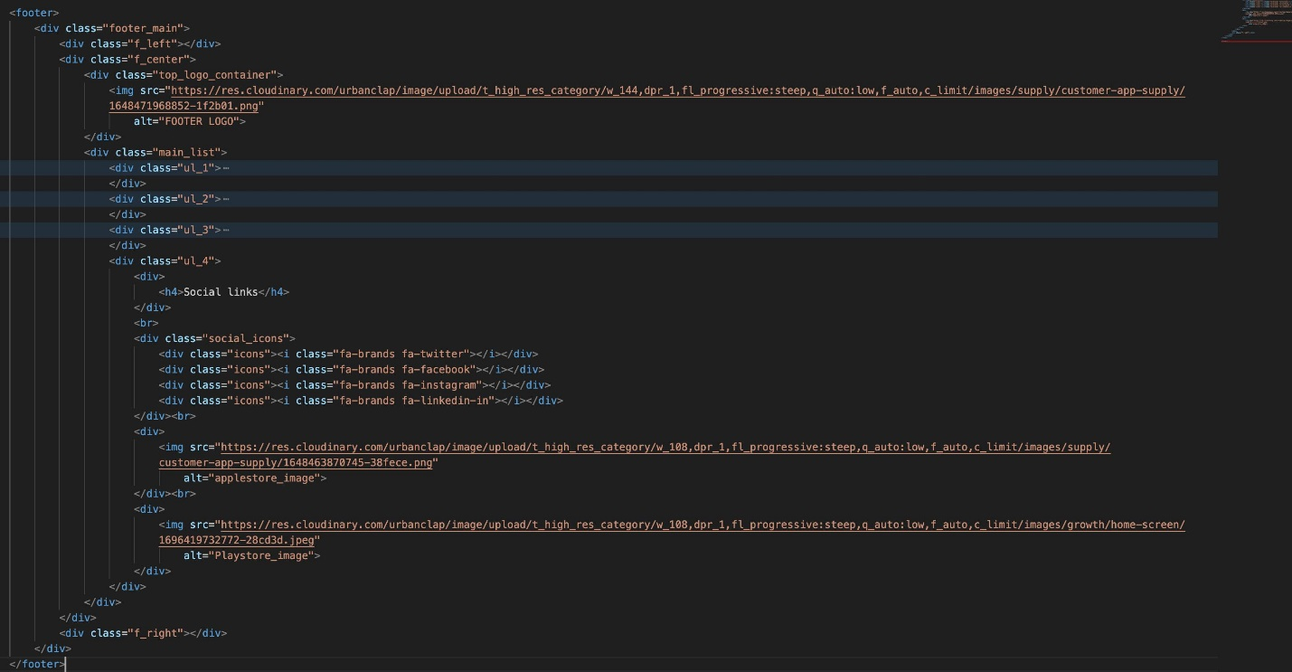
* Testing :
  + All the images are visible properly.
  + All the buttons are working properly.
  + CDN & Bootstrap is working properly.
* Challenges and Solutions:
  + Challenges : Lay outing
  + Solution :
    - Dividing the main container into three different containers helps a lot.
    - Arranging Social Media Icons.